Big Mountain Resort Report

Big Mountain Ski Resort is currently facing a financial quandary. A new ski lift, purchased to help distribute visitors across the mountain, is expected to increase operating costs by about $1.5 million per season. Investors hope to recoup these costs and maintain the current profit margin of 9.2%. To that end, we have employed data visualization and a linear regression model to determine methods of increasing profits or decreasing operating costs.

The above figure compares Skiable Terrain in acres to the acreage covered by snow making machines. In the figure, the larger black point represents Big Mountain Resort. As we can see, Big Mountain Resort has nearly twice the skiable terrain of any other ski resort with 600 of those acres being serviced by snow making machines. If the snow machines were to be shut off, the resort would still have far more skiable terrain than any competitor. Furthermore, Big Mountain Resort also has 600 acres of skiable terrain covered in stadium lighting for night skiing, which is not very popular. Removing the snow machines presents a sizable opportunity to reduce operating costs without impacting the experience of the skiers, who have more acreage than they could ever find at any other resort. Similarly, cutting down on the night skiing acreage would help to relieve variable costs without hurting customer satisfaction.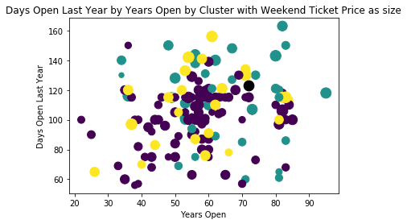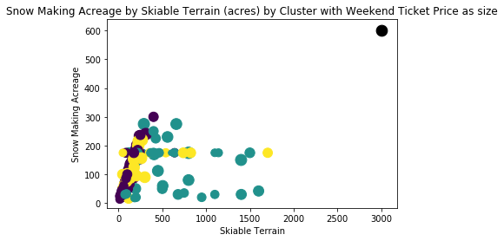

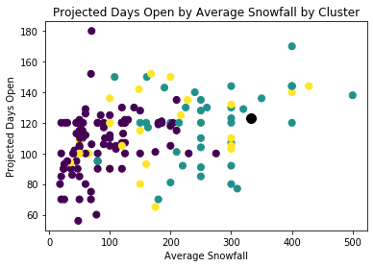

The above figures represent the distribution of the length of the skiing season at each resort mediated by the number of years the resort has been open and average yearly snowfall respectively. Big Mountain Resort is represented in each figure by the black data point. The upper figure suggests that Big Mountain’s Weekend ticket price (represented by point size) is less than many of its competitors with comparable season length and number of years open. In fact, our model predicts that, based off Big Mountain’s features, the expected price for an adult weekend lift ticket is $90.88. Big Mountain is currently charging only $81.00 for a lift ticket. This represents a great deal of room to increase revenue and recover the previous profit margin.

The second figure shows us that Big Mountain receives a great deal more snow than many of its competitors, and yet, is open no longer than the standard 120 days per season. The climate allows for Big Mountain to keep its doors open much longer than its competitors. By extending the season for a week or two on either end, Big Mountain gains more possible customers and an edge over its competitors. This will help bolster revenue as well.